ASSIGNMENT 9

Snikitha Bommena

700744412

Loss of the source code

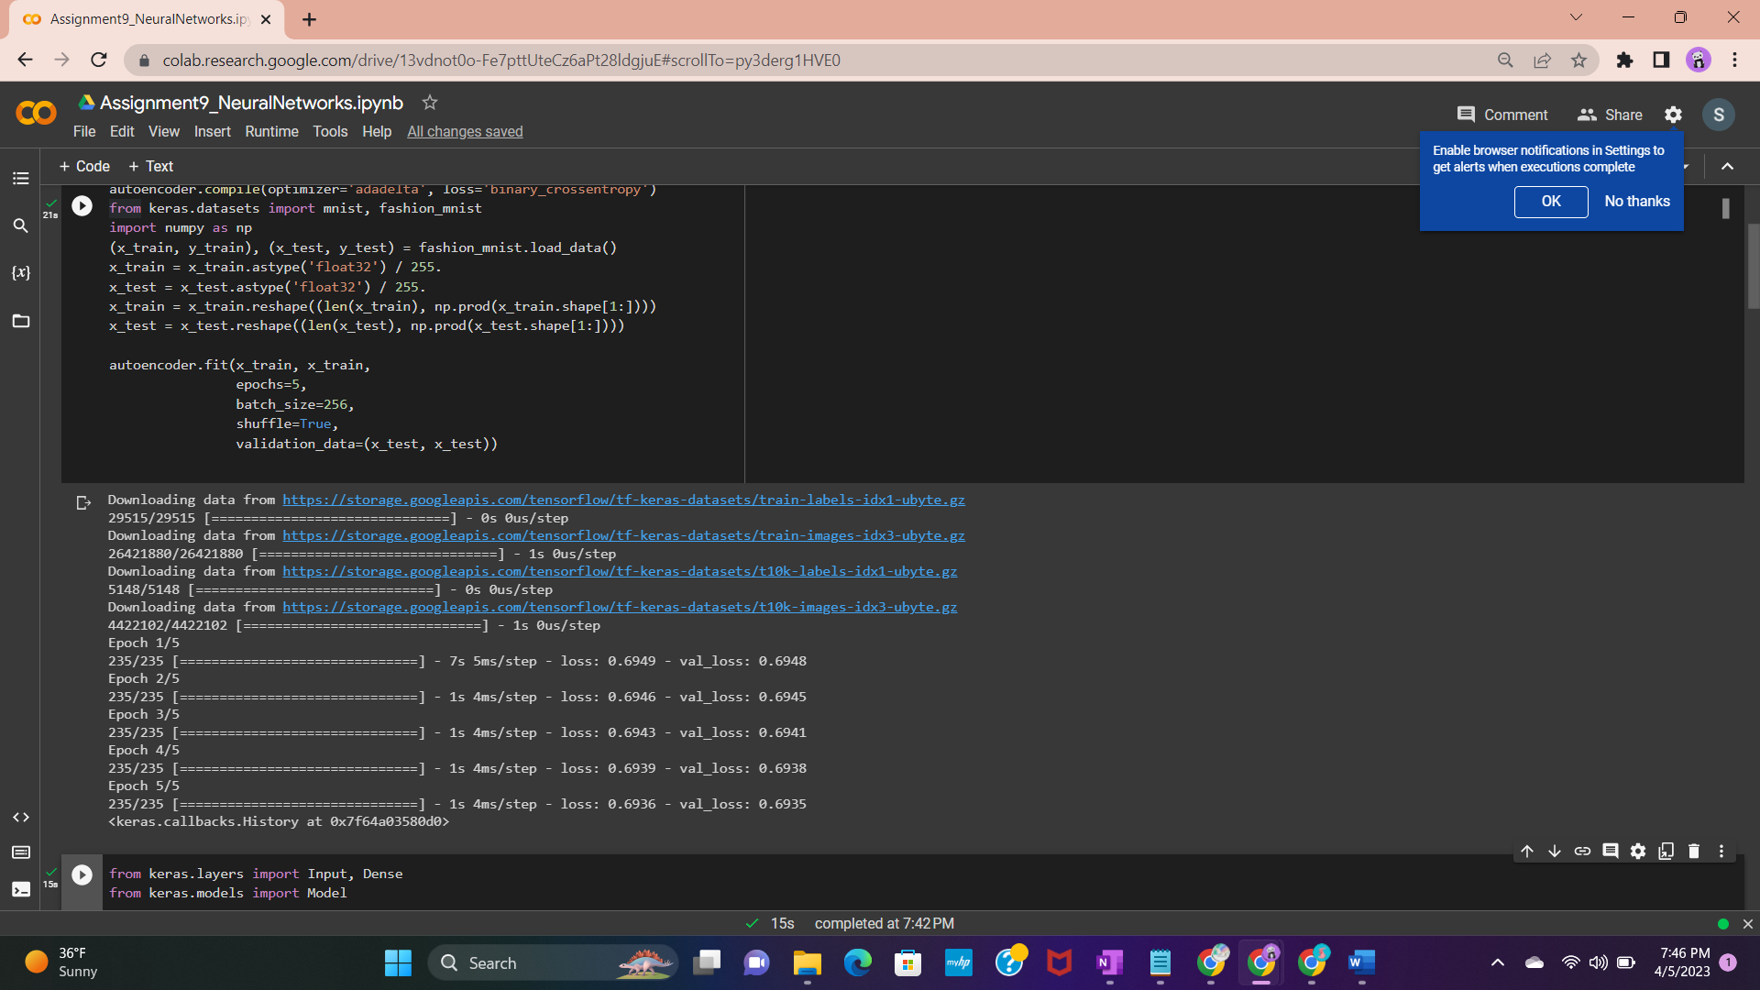

QUESTION 1 : Add one more hidden layer to autoencoder

QUESTION 2 : Do the prediction on the test data and then visualize one of the reconstructed version of that test data. Also, visualize the same test data before reconstruction using Matplotlib

QUESTION 3 : Repeat the question 2 on the denoising autoencoder

QUESTION 4 : plot loss and accuracy using the history object

